# Mass Moment of Inertia

The mass moment of inertia of an object ($J$) plays a similar role in rotational motion as the role that mass plays in translational motion: the mass moment of inertia determines how rotational velocity is affected by applied torque. This of course depends not only on the mass of the object, but also on how the mass is distributed around the rotation axis.

|  |  |
| --- | --- |
| Translational Motion | Rotational Motion |
| $$∑F=ma$$ | $$∑τ=J\dot{ω}$$ |

We need to find the moment of inertia matrix for the quadcopter vehicle. We will use “J” for mass moment of inertia, though various sources use different conventions for this. It is important to note here that the quadcopter vehicle is assumed to be perfectly symmetric about the x, y, and z axis and to have its center of mass at the geometric center of the arms. With these assumptions, the $J^{b}$ matrix (shown below) becomes a diagonal matrix (note that this relates to our choice of x and y axis positions, but is preserved in both “+” and “X” configurations). The $J_{x}$ and $J_{y}$ terms are also taken to be identical due to this symmetry. The matrix is:

$$J^{b}= \left[\begin{matrix}J_{x} & 0 & 0 \\ 0 & J_{y} & 0 \\ 0 & 0 & J_{z}\end{matrix}\right]$$

## Approach

* Break the quadcopter vehicle into separate components. Model each of these as a simplified geometric shape of constant internal density.
* Measure and weigh each component.
* Utilize the parallel-axis theorem to determine the moment of inertia contribution of each component about the x, y, and z axes of the vehicle.
* Sum the inertias for every component about each axis to find the total moment of inertia matrix for the vehicle

We utilized the parallel-axis theorem in order to determine the mass moment of inertia of individual components our chosen axes, given an individual component’s mass moment of inertia about a parallel axis through the center of mass of that component and the perpendicular distance between the two axes. The parallel-axis equation is:

$$J_{parallel-axis}=J_{COM}+mr^{2}$$

$J_{COM}$ is the moment of inertia of an individual component about its own axis (which passes through the components center of mass) parallel to the axis we wish to “move” it to. In the equation above, $m$ is the mass of the component, and $r$ is the perpendicular distance between the parallel axes. Note that sign of r is not important since the value is squared.

## Motors: solid cylinders (Jx,M, Jy,M, and Jz,M)

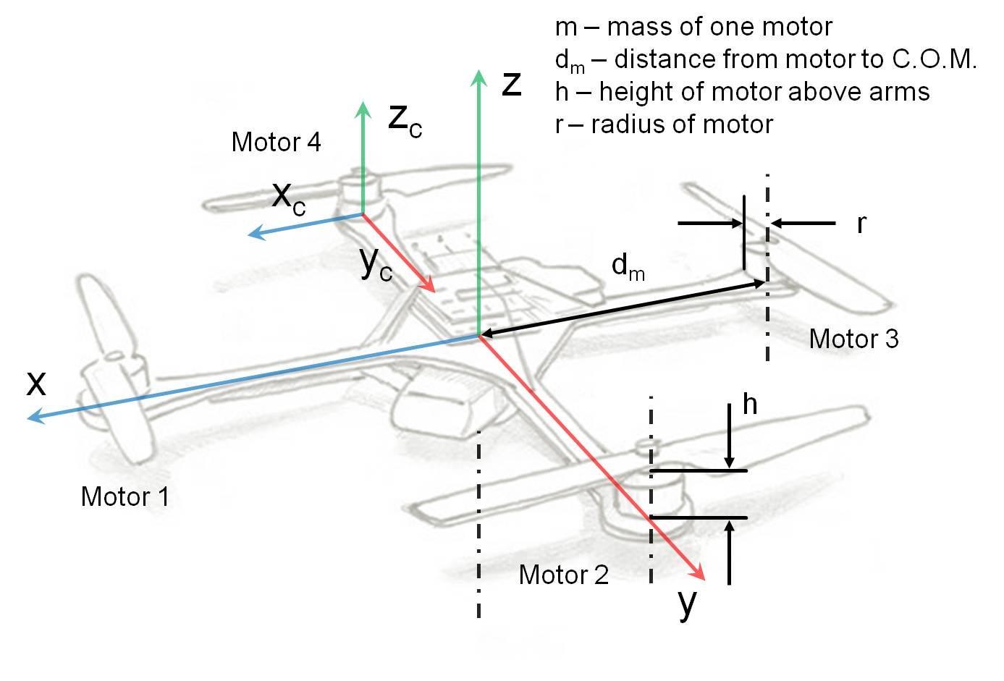

**Equations Needed:**

|  |  |
| --- | --- |
| Cylinder rotating around an end diameter | Cylinder rotating around a central axis |
| Edited_Cylinder.jpg | central axis.jpg |
|  |  |
| X and Y axes | Z axis |

$J_{x,M}$ and $J_{y,M}$

$$J_{x,M}=J_{y,M}=2\left[\frac{1}{4}mr^{2}+\frac{1}{3}mh^{2}\right]+2\left[\frac{1}{4}mr^{2}+\frac{1}{3}mh^{2}+m{d_{m}}^{2}\right]$$

To find $J_{x,M}$ and $J_{y,M}$ we use the equation for a cylinder rotating around an end diameter (see figure above). Say we are looking to find $J_{y,M}$, for example. The first bracketed term in the equation is for motors 1 and 3, which are rotating around an end diameter coinciding with the x-axis of the quadcopter, therefore the distance term ($mr^{2}$– parallel axis theorem) is zero and is omitted. The second bracketed term in the equation is for motors 2 and 4, which are at a diameter that is offset but *parallel* to the x-axis of the quad. We have a distance term at the end here ( $mr^{2}$– except we use dm instead of r for clarity). This is the perpendicular distance between the rotation axis of the motor and the actual x-axis of the quad. Because of the symmetry of the vehicle, $J_{x,M}$ is going to be the same value as $J_{y,M}$.

$$J_{z,M}$$

$$J_{z,M}=4\left[\frac{1}{2}mr^{2}+m{d_{m}}^{2}\right]$$

To find $J_{z,M}$ we use the equation for a cylinder rotating around a central axis (see Figure above). In this case all 4 motors are rotating around a central axis that is offset but *parallel* to the z-axis of the quad. We have a distance term at the end here as well, $m{d_{m}}^{2}$, which is the perpendicular distance between the rotation axis of the motor and the actual z-axis of the quad. The distance term, dm, will be the same value for all 4 motors, hence incorporating all the motors into just the 1 equation and multiplying the entire bracketed term by 4.

## ESC’s: thin flat plates (Jx,S, Jy,S, and Jz,S)

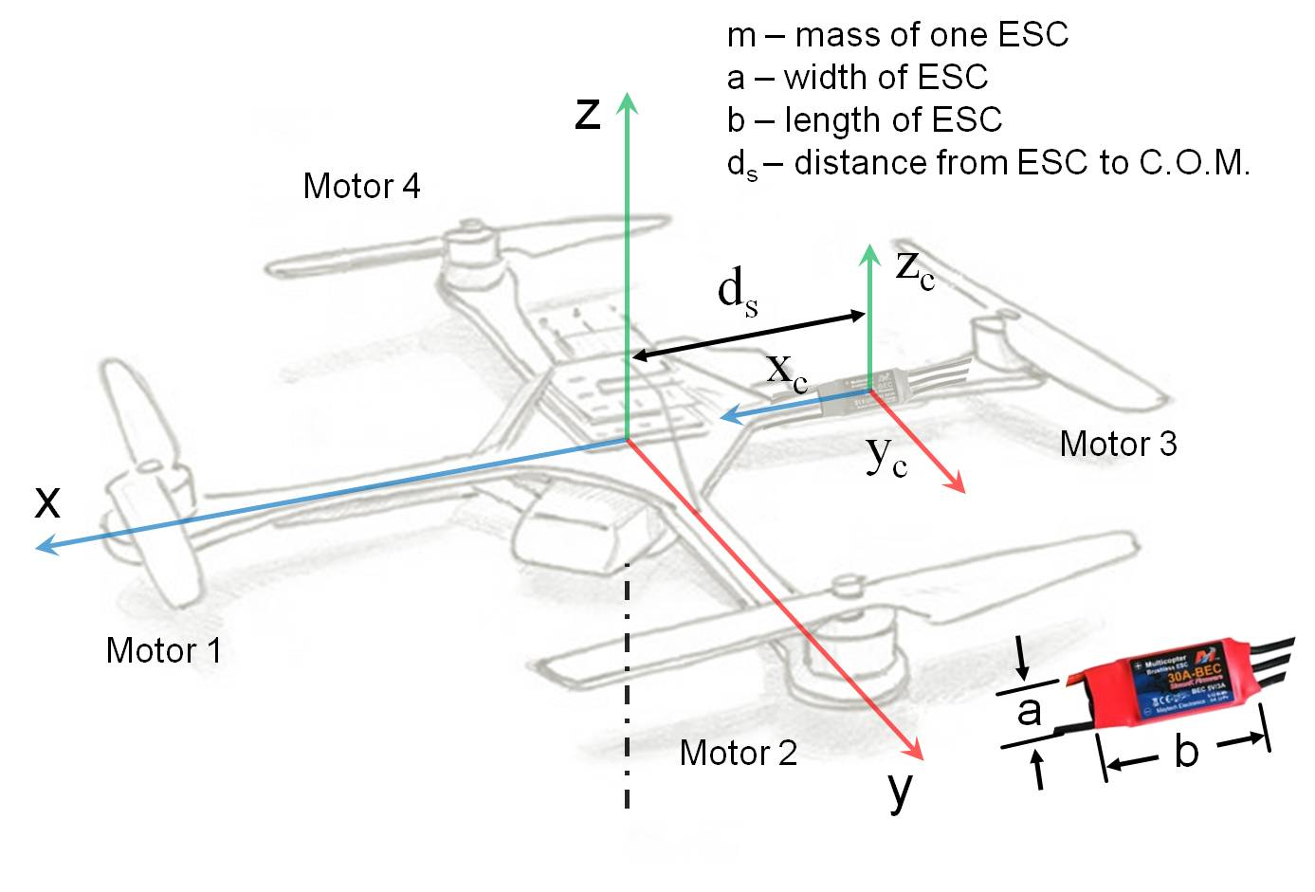

**Equations Needed:**

|  |  |  |
| --- | --- | --- |
| Flat plate rotating around X, Y, and Z axes | | |
|  | | |
| $$J_{COM,x}=\frac{1}{12}mb^{2}$$ | $$J_{COM,y}=\frac{1}{12}ma^{2}$$ | $$J_{COM,z}=\frac{1}{12}m\left(a^{2}+b^{2}\right)$$ |

$J_{x,S}$ and $J_{y,S}$

$$J_{x,S}=J_{y,S}=2\left[\frac{1}{12}ma^{2}\right]+2\left[\frac{1}{12}mb^{2}+m{d_{s}}^{2}\right]$$

To find $J_{x,S}$ and $J_{y,S}$ we chose to use the equations for a flat plate rotating around the x and y axes (see figure above). Suppose we are looking to find $J_{x,S},$ for example. The first bracketed term in the equation is for ESC’s 1 and 3 (#’s correspond to which motor they are connected with), which are rotating around an axis coinciding with the x-axis of the quad, therefore the distance term ($mr^{2}$– parallel axis theorem) is zero. The second bracketed term in the equation is for ESC’s 2 and 4, which are rotating around an axis that is offset but *parallel* to the x-axis of the quad. We have a distance term at the end here ( $mr^{2}$– except we use $d_{S}$ instead of r). This is the perpendicular distance between the rotation axis of the ESC and the actual x-axis of the quad. Because of the symmetry of the vehicle, Jy,S is going to be the same value as $J_{x,S}$.

$$J_{z,S}$$

$$J_{z,S}=4\left[\frac{1}{12}m\left(a^{2}+b^{2}\right)+m{d_{s}}^{2}\right]$$

To find Jz,S we use the equation for a flat plate rotating around the z-axis (see Figure above). In this case all 4 ESCs are rotating around an axis that is offset but *parallel* to the z-axis of the quad. We have a distance term at the end here as well, $m{d_{S}}^{2}$, which is the perpendicular distance between the rotation axis of the ESC and the actual z-axis of the quad. The distance term, $d_{s}$, will be the same value for all 4 ESCs.

## Central HUB: solid cylinder (Jx,H, Jy,H, Jz,H)

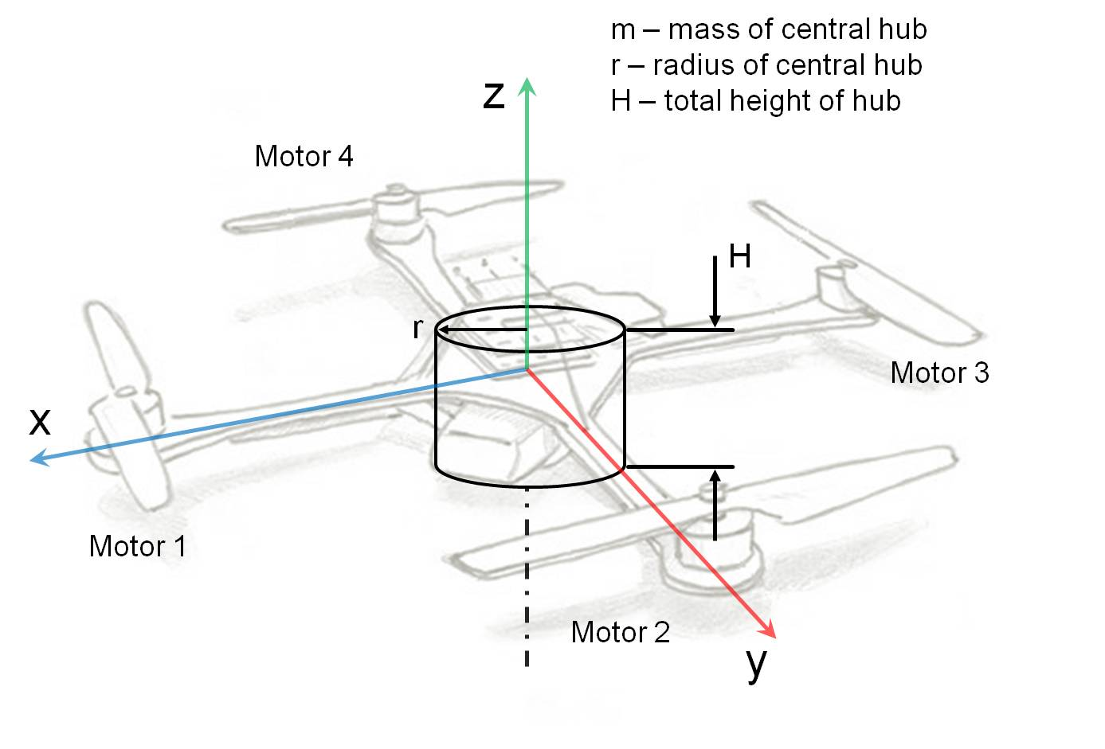

**Equations Needed:**

|  |  |
| --- | --- |
| Cylinder rotating around a central diameter | Cylinder rotating around a central axis |
| Cylinder edit.png | central axis.jpg |
|  |  |
| X and Y axes | Z axis |

$J_{x,H}$ and $J_{y,H}$

$$J_{x,H}=J_{y,H}=\left[\frac{1}{4}mr^{2}+\frac{1}{12}mH^{2}\right]$$

To find $J_{x,H}$ and $J_{y,H}$ we use the equation for a cylinder rotating around a central diameter (see figure above). Say we are looking to find $J_{x,H}$, for example. The entire bracketed term is for the central HUB, which is rotating around a central diameter coinciding with the x-axis of the quad, therefore the distance term ($mr^{2}$– parallel axis theorem) is zero. Because of the symmetry of the vehicle, $J_{y,H}$ is going to be the same value as $J_{x,H}$.

$$J_{z,H}$$

$$J_{z,H}=\left[\frac{1}{2}mr^{2}\right]$$

To find $J_{z,H}$ we use the equation for a cylinder rotating around a central axis (see Figure above). In this case the hub is rotating around a central axis that coincides with the z-axis of the quad, therefore the distance term is zero.

## Arms: long cylindrical rods (Jx,A, Jy,A, Jz,A)

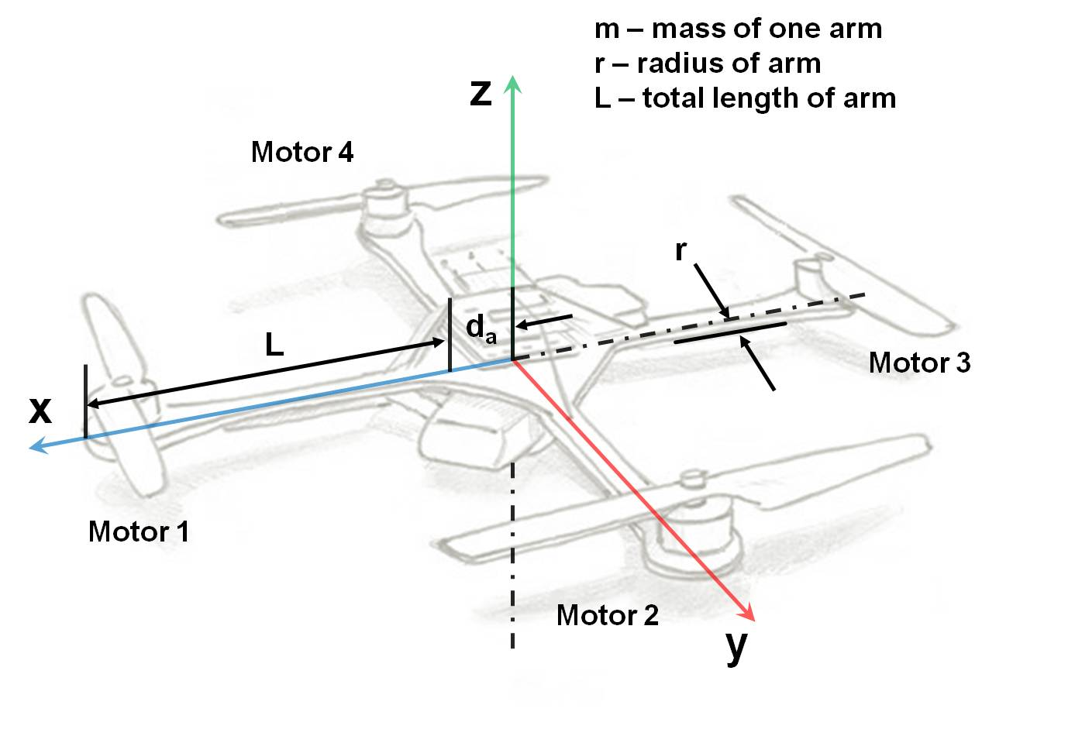

**Equations Needed:**

|  |  |
| --- | --- |
| Cylinder rotating around a central axis | Cylinder rotating around an end diameter |
| central axis.jpg | Edited_Cylinder.jpg |
|  |  |
| X and Y axes | X, Y, and Z axes |

$J_{x,A}$ and $J_{y,A}$

$$J_{x,A}=J_{y,A}=2\left[\frac{1}{2}mr^{2}\right]+2\left[\frac{1}{4}mr^{2}+\frac{1}{3}mL^{2}+{md_{A}}^{2}\right]$$

To find $J_{x,A}$ and $J_{y,A}$ we use the equations for a cylinder rotating around a central axis, and also an end diameter (see figure above). Say we are looking to find $J_{x,A}$, for example. The first bracketed term in the equation is for arms 1 and 3, which are rotating around a central axis coinciding with the x-axis of the quad, therefore the distance term ($mr^{2}$– parallel axis theorem) is zero. The second bracketed term in the equation is for arms 2 and 4 which are rotating around an end diameter located at a distance “ $d_{A}$” from the x-axis of the vehicle, so the parallel axis theorem term here is $m{d_{A}}^{2}$. Because of the symmetry of the vehicle, $J_{y,A}$ is assumed to be the same as $J_{x,A}$.

$J_{z,A}$

$$J_{z,A}=4\left[\frac{1}{4}mr^{2}+\frac{1}{3}mL^{2}+m{d_{A}}^{2}\right]$$

To find Jz,A we use the equation for a cylinder rotating around an end diameter (see Figure above). In this case all 4 arms are rotating around an end diameter located at a distance “ $d_{A}$” from the z-axis of the vehicle, so the parallel axis theorem term is $m{d_{A}}^{2}$. Also, because the quad is symmetrical and each arm has the same length we multiply the entire bracketed term by 4.